|  |  |
| --- | --- |
| **Analyzing Ramadan Campaign**  By: Rian Qadir |  |

Table of Contents

1. Overview 2

2. Data Processing and Analytical Approach 2

2.1 TikTok Data Processing 2

2.2 Meta Data Processing 3

2.3. Snapchat Data Processing 4

3. Key Insights and Performance Evaluation 5

3.1 Platform Comparison 5

3.2 Comprehensive Performance by Platform 5

3.3 Campaign-Level Performance 6

3.4 Video Completion Rate (VTR) by Market and Platform 7

3.5 Engagement, CPC, CTR, and VTR Overview 8

3.6 Audience Segmentation Analysis 9

4. Visualizations 10

5. Macros Implementation: 10

5.1 Data Refresh Macro: 10

5.2 Performance Filter Macro: 11

5.3 Conditional Formatting Macro: 12

5.4 Formatting Summary Sheet Macro: 12

6. Conclusion: 14

7. Recommendations: 14

## 1. Overview

This report outlines the analysis of a Ramadan-focused digital marketing campaign run on three prominent platforms: TikTok, Meta, and Snapchat. The main objective was to evaluate the campaign's performance across these channels, identify significant trends, and provide data-backed suggestions for future campaigns. The workflow involved thorough data cleansing, preparation, constructing Pivot Tables, and utilizing advanced Macros to simplify and optimize the analysis process.

## 2. Data Processing and Analytical Approach

The data required significant cleaning and structuring to ensure its accuracy and consistency. The following sections detail the steps to clean and process the datasets from each platform.

### 2.1 TikTok Data Processing

**Initial Data Layout:**

* **Columns:** Source Sheet, Market, Channel, Campaign Name, Campaign Details, Campaign ID, Audience, Duration, Language, Format, Creative Variation, Amount Spent, Clicks, CPC, Paid Reach, Total Impressions, CTR, CPM, 2-Second Views, Video Completions, VTR (2 Seconds), VTR (Complete), Total Engagement, Engagement Rate.

**Key Issues:**

* Duplicative information in multiple columns.
* Irregular data formats in text fields.
* Potential hidden or corrupt characters in the Campaign Name field.

**Processing Steps:**

|  |
| --- |
| ***Goal:*** The Campaign Name field contained multiple segments of information, separated by symbols. These need to be split for easier analysis. |
| ***Action****:* Employed Excel’s Text-to-Columns tool, using underscores (_) and tildes (~) as separators to break the Campaign Name into meaningful columns such as Channel Name, Audience, Market, and Objective. |
| ***Outcome:*** The Campaign Name was successfully split into separate attributes. |

1. **Campaign Name Breakdown:**
2. **Removing Duplicates:**

|  |
| --- |
| ***Goal:*** Eliminate unnecessary columns that contain redundant or irrelevant data. |
| ***Action:*** Removed columns like Ad Group Name and Market, which had been extracted elsewhere. Also removed the Ad Name field after extracting useful details. |
| ***Outcome:*** The dataset was cleaner and more concise. |

1. **Standardizing Text Fields:**

|  |
| --- |
| ***Goal:*** Ensure text fields are consistent and free from hidden characters. |
| ***Action:*** Applied Excel's TRIM function to remove leading/trailing spaces and CLEAN function to strip out non-printable characters. |
| ***Outcome:*** Text fields were consistent and error-free. |

1. **Metric Computation:**

|  |
| --- |
| ***Goal:*** Add relevant metrics to enhance analysis. |
| ***Action:*** Calculated CTR (Clicks / Impressions * 100) and CPC (Cost Per Click), adding them as new columns. |
| ***Outcome:*** The dataset was expanded with critical metrics |

.

1. **Consistent Formatting:**

|  |
| --- |
| ***Goal:*** Standardize number and date formats. |
| ***Action:*** Reformatted all dates to DD/MM/YYYY and ensured numerical values had appropriate formatting with separators. |
| ***Outcome:*** Data was uniform and ready for analysis. |

1. **Validation:**

|  |
| --- |
| ***Goal:*** Ensure data integrity before proceeding with deeper analysis. |
| ***Action:*** Cross-verified key metrics like CTR and CPC with raw data and used conditional formatting to detect anomalies. |
| ***Outcome:*** The data was validated and ready for analysis. |

### 2.2 Meta Data Processing

**Initial Data Layout:**

* **Columns:** Source sheet, Market, Campaign attributes, Campaign Name, Campaign ID, Duration, Audience, Language, Format, Creative variations, Reach, Impressions, Amount spent (USD), Link clicks, CPC, 3-second video plays, Video plays at 100%, CTR(all), CTR Evaluation, all ctr evaluation, VTR, Age Group, Post engagement, total engagement, Engagement Rate.

**Key Issues:**

* Improper formatting of numerical and percentage-based columns.
* Inconsistent text formatting across records.

**Processing Steps:**

1. **Text Standardization:**

|  |
| --- |
| ***Goal:*** Normalize text data for consistency. |
| ***Action:*** Converted all text to uppercase to avoid case-sensitive discrepancies and used SUBSTITUTE and TRIM functions to remove special characters and extra spaces. |
| ***Outcome****:* Text data was cleaned and standardized. |

1. **Data Type Adjustment:**

|  |
| --- |
| ***Goal:*** Ensure proper data types are applied to all columns. |
| ***Action:*** Verified that numerical columns (e.g., Impressions, Clicks, Spend) were formatted correctly and checked date formats. |
| ***Outcome:*** Data types were properly assigned, reducing the risk of errors. |

1. **Column Consistency Check:**

|  |
| --- |
| ***Goal:*** Ensure that all columns are complete and consistent. |
| ***Action:*** Used data validation techniques to check for missing or anomalous values, leveraging COUNTIF and ISBLANK functions. |
| ***Outcome:*** All columns were confirmed to have complete and consistent data. |

1. **Metric Creation:**

|  |
| --- |
| ***Goal:*** Enhance the dataset by adding new performance metrics. |
| ***Action:*** Calculated CTR (Clicks/Impressions * 100) and CPC (Spend/Clicks) and added them as new columns. |
| ***Outcome:*** The dataset was enriched with additional performance metrics. |

### 2.3. Snapchat Data Processing

**Initial Data Layout:**

* **Columns:** Source sheet, Market, Channel, Campaign ID, Campaign Name, Campaign Strategy, Audience, Duration, Language, Format, Creative Variation, Amount Spent, Engagement Rate, Engagement, Clicks, CPC, CTR, Clicks Rate, Paid Reach, Total Impressions, Paid Frequency, Paid eCPM, 2 Second Video Views, Video Completions, VTR%

**Key Issues:**

* Confusing column names (e.g., “Swipe Ups” vs. “Clicks”).
* Missing important metrics like CTR and CPC.

**Processing Steps:**

1. **Renaming Columns and Calculating Metrics:**

|  |
| --- |
| ***Goal****:* Clarify column names and introduce key performance metrics. |
| ***Action****:* Renamed “Swipe Ups” to “Clicks” and calculated CTR and CPC, adding them as new columns. |
| ***Outcome:*** The dataset was clearer, with new metrics added for deeper analysis. |

1. **Consistent Formatting:**

|  |
| --- |
| ***Goal:*** Ensure consistency in numeric values. |
| ***Action:*** Applied appropriate formatting for key metrics like Clicks, Impressions, and Spend, using decimal places and separators for clarity. |
| ***Outcome:*** Numeric values were easier to interpret and compare. |

1. **Detecting Anomalies:**

|  |
| --- |
| ***Goal:*** Identify and address outliers or errors in the data. |
| ***Action:*** Correct any detected anomalies by using conditional formatting to highlight extreme values. |
| ***Outcome****:* The dataset was accurate and reliable for analysis. |

1. **Validating Data:**

|  |
| --- |
| ***Goal****:* Confirm that all calculated metrics are accurate. |
| ***Action****:* Cross-checked calculated metrics like CTR and CPC with the raw data, ensuring consistency. |
| ***Outcome:*** The dataset was confirmed to be accurate and ready for further analysis. |

## 3. Key Insights and Performance Evaluation

### 3.1 Platform Comparison

|  |  |
| --- | --- |
| **Platform** | **Sum of CPC** |
| MetaData cleaned | 120.7806754 |
| Snapchat cleaned data | 25.03421191 |
| Tiktok cleaned Data | 35.23299865 |

The analysis compared the performance across TikTok, Meta, and Snapchat using key metrics, particularly focusing on Cost Per Click (CPC):

* **CPC for Meta:** 120.78
* **CPC for Snapchat:** 25.03
* **CPC for TikTok:** 35.23

These results indicate that Meta incurred a significantly higher CPC, while Snapchat and TikTok offered more cost-efficient click generation.

### 3.2 Comprehensive Performance by Platform

A more detailed analysis was performed to aggregate the key metrics, including Clicks, CPC, and Amount Spent, across Meta, Snapchat, and TikTok. The following summarizes the performance on each platform:

* **Meta:**
  + **Clicks:** 419,081
  + **CPC:** 120.78 USD
  + **Amount Spent:** 53,113.53 USD
* **Snapchat:**
  + **Clicks:** 54,794
  + **CPC:** 25.03 USD
  + **Amount Spent:** 23,049.20 USD
* **TikTok:**
  + **Clicks:** 79,388
  + **CPC:** 35.23 USD
  + **Amount Spent:** 52,192.57 USD

|  |  |  |  |  |  |
| --- | --- | --- | --- | --- | --- |
| **Platform** | **Count of Platform** | **Count of Market** | **Sum of CPC** | **Sum of Amount Spent** | **Sum of Clicks** |
| MetaData cleaned | 426 | 426 | 120.7806754 | 53113.53 | 419081 |
| Snapchat cleaned data | 53 | 53 | 25.03421191 | 23049.2 | 54794 |
| Tiktok cleaned Data | 72 | 72 | 35.23299865 | 52192.57 | 79388 |
| **Grand Total** | **551** | **551** | **181.047886** | **128355.3** | **553263** |

**Analysis:**  
Meta achieved the highest number of clicks and had the highest total spend. However, it also recorded the highest Cost Per Click (CPC) at 120.78 USD, which indicates a much lower cost efficiency compared to Snapchat and TikTok. Despite having fewer clicks, Snapchat showed the most cost-effective performance, with a CPC of 25.03 USD. TikTok sits in between, with a moderate CPC of 35.23 USD, providing a balance between cost and performance.

This suggests that, while Meta reaches a broader audience, the cost per interaction is substantially higher. In contrast, Snapchat offers a more budget-friendly approach, delivering reasonable click volumes at a much lower cost. TikTok also offers significant reach with relatively moderate spending, positioning it as a strong contender for future campaigns aiming to balance budget and engagement.

### 3.3 Campaign-Level Performance

The campaign performance was closely analyzed by examining Total Impressions, Clicks, and Click-Through Rate (CTR). Below are the top-performing campaigns:

**Top Campaigns by Impressions**:

**Campaign:** CN~MCDRamadan_CH~FBIG_MK~RIY_TG

* Impressions: 16,873,762
* Clicks: 31,766
* CTR: 9.41%

**Campaign:** CN~MCDRamadan_CH ~Tiktok_MK~JED_TG:

* Impressions: 15,307,011
* Clicks: 17,744
* CTR: 8.82%

**Top Campaign by CTR:**

**Campaign:** CN~MCDRamadan_CH ~Tiktok_MK~AE_TG

* CTR: 24.85%

|  |  |  |  |
| --- | --- | --- | --- |
| **Campaign Name** | **Sum of Total Impressions** | **Sum of Clicks** | **Sum of CTR** |
| CN~MCDRamadan_CH~Tiktok_MK~AE_TG | 11363327 | 12769 | 24.85% |
| CN~MCDRamadan_CH~Tiktok_MK~KWT_TG | 5882789 | 6936 | 20.88% |
| CN~MCDRamadan_CH~Tiktok_MK~RIY_TG | 56264 | 131 | 13.97% |
| CN~MCDRamadan_CH~Tiktok_MK~BAH_TG | 2098862 | 3613 | 11.76% |
| CN~MCDRamadan_CH~Tiktok_MK~QAT_TG | 4128788 | 6429 | 10.29% |
| CN~MCDRamadan_CH~FBIG_MK~RIY_TG | 16873762 | 31766 | 9.41% |
| CN~MCDRamadan_CH~Tiktok_MK~JED_TG | 15307011 | 17744 | 8.82% |
| CN~MCDRamadan_CH~Tiktok_MK~OMA_TG | 2567839 | 0 | 0.00% |
| **Grand Total** | **58278642** | **79388** | **100.00%** |

**Analysis:**

The campaign targeting the Riyadh market via Facebook and Instagram (CN~MCDRamadan_CH~FBIG_MK~RIY_TG) delivered the highest number of impressions at 16.87 million, leading to 31,766 clicks and achieving a respectable CTR of 9.41%. The TikTok campaign aimed at Jeddah (CN~MCDRamadan_CH ~Tiktok_MK~JED_TG) generated a slightly lower click count of 17,744 from over 15 million impressions, yielding a CTR of 8.82%.

In contrast, the campaign targeting the AE market on TikTok (CN~MCDRamadan_CH ~Tiktok_MK~AE_TG) stands out with a remarkable CTR of 24.85%, indicating strong engagement with the audience in that region despite fewer overall impressions compared to the Riyadh campaign.

### 3.4 Video Completion Rate (VTR) by Market and Platform

The analysis of Video Completion Rate (VTR) across various markets and platforms revealed the following insights:

* **MetaData cleaned:**
  + Highest VTR recorded in:
    - AE (12.79%)
    - JED (14.13%)
* **Snapchat cleaned data:**
  + Strong VTR performance in:
    - BH (2.94%)
    - RIY (2.18%)
* **TikTok cleaned data:**
  + Lower VTR observed in:
    - AE (0.06%)
    - KWT (0.06%)



**Analysis:**

The MetaData cleaned platform showed a significant engagement with users in the AE and Jeddah markets, with VTRs reaching 12.79% and 14.13%, respectively. Snapchat cleaned data, while reporting lower VTRs overall, still saw notable results in the Bahrain and Riyadh markets, albeit at much lower levels of 2.94% and 2.18%. TikTok cleaned data exhibited very low VTRs in both the AE and Kuwait markets, each at 0.06%, indicating a weaker performance regarding video completion rates on that platform.

This suggests that the MetaData cleaned campaigns performed significantly better in maintaining audience engagement through video content, especially in key markets like AE and JED. Conversely, TikTok's low VTR indicates a potential need for adjusting video strategies in those markets to enhance viewer retention.

### 3.5 Engagement, CPC, CTR, and VTR Overview

A comprehensive comparison was made between MetaData cleaned, Snapchat cleaned data, and TikTok cleaned data, focusing on key performance metrics: Engagement Rate, Cost Per Click (CPC), Click-Through Rate (CTR), and Video Completion Rate (VTR). Here's the summary:

**Analysis:**

MetaData cleaned stands out significantly with a robust **Engagement Rate** of 67.97% and a **VTR** of 61.25%, though its **CPC** is quite high at $120.78. This suggests that while MetaData cleaned yields strong audience interaction and video retention, it comes at a higher cost per click.

On the other hand, **Snapchat cleaned data** shows a much more cost-efficient **CPC** of $25.03 but lags in terms of **Engagement Rate** (0.19%) and **VTR** (8.34%). Despite the lower engagement, it remains a more cost-effective option.

**TikTok cleaned data** presents a moderate **CPC** of $35.23 but suffers from the lowest **CTR** (0.07%) and **VTR** (0.24%), indicating challenges in generating significant engagement and retaining audience attention through video content.

The findings suggest that while MetaData cleaned offers high-quality engagement, its cost-efficiency may be a concern. Snapchat proves more cost-effective, while TikTok struggles with engagement, hinting at the need for campaign optimization to improve performance.



### 3.6 Audience Segmentation Analysis

The final section of the analysis evaluates audience segmentation by comparing two key demographics—Boomers and Millennials—across several metrics: Link Clicks, Impressions, Amount Spent, and Conversion Rate.

**Analysis:** Millennials outperformed Boomers across all key metrics, with over **331,000 link clicks** compared to Boomers' **87,622**, and more than three times the number of **impressions**. Although both groups exhibit relatively low conversion rates, Millennials still demonstrate a slightly higher **conversion rate** at 0.40%, compared to Boomers' 0.35%.

The data suggests that Millennials engage more with the ads and convert at a marginally better rate, making them a more valuable target demographic for future campaigns. The higher spend on Millennials also appears to yield stronger results in terms of link clicks and impressions, indicating a more efficient use of marketing resources when targeting this group.



## 4. Visualizations

The concluding section presents the final dashboard that incorporates all visualizations crafted throughout the analysis. This dashboard is designed to enhance understanding, facilitate data interpretation, and highlight key insights derived from the campaign data. Each visualization serves to illustrate important metrics and trends, allowing for a comprehensive view of the campaign's performance across platforms.

* **Dashboard Components:**
  + Overall Performance Metrics
  + Platform Comparison
  + Campaign Performance Analysis
  + Audience Segmentation Insights
  + Engagement Trends Over Time



## Macros Implementation:

To streamline the analysis and ensure the process could be easily replicated, I recorded and implemented several macros:

### 5.1 Data Refresh Macro:

* + **Function:** Automatically refresh all Pivot Tables with the latest data.
  + **Steps:** Created a macro that refreshes all Pivot Tables across the workbook with a single click.
  + **Outcome:** Streamlined the data update process, ensuring the analysis was always based on the most current data.

[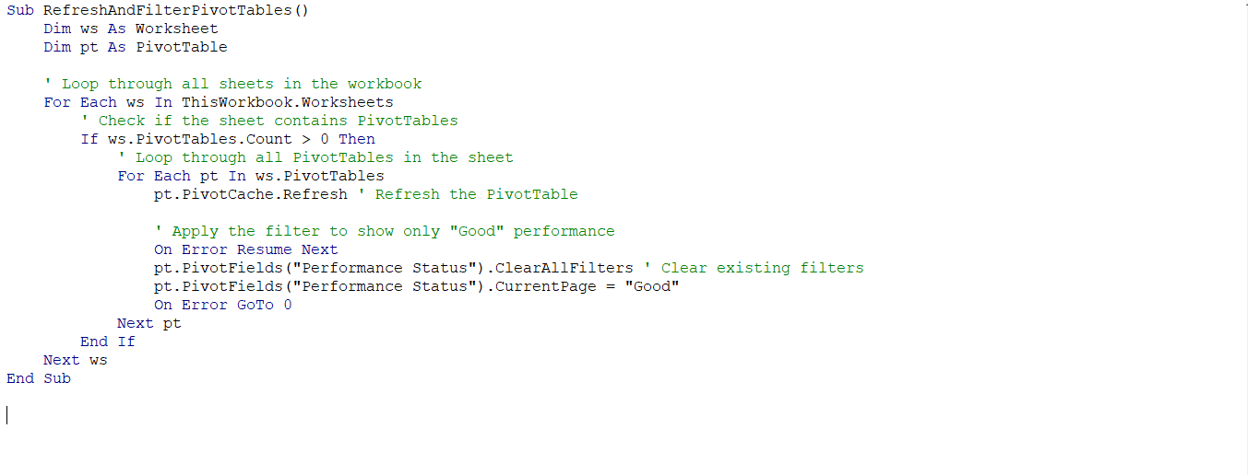](https://private-user-images.githubusercontent.com/98176045/364347704-dc5f97d8-41da-4d76-ad67-faf29b6bc1a7.png?jwt=eyJhbGciOiJIUzI1NiIsInR5cCI6IkpXVCJ9..7vIB6zljUaUhIxmOr0i6BZ6FPgI-lgA3Fe7n5e5eLKA)

### 5.2 Performance Filter Macro:

* + **Function:** Filter the summary sheets to highlight campaigns with a "Good" performance status, applying a green highlight.
  + **Steps:** Recorded a macro that automatically applies a filter to display only the campaigns with a "Good" performance status. Implemented conditional formatting to highlight these top-performing campaigns in green.
  + **Challenges:** Filtering Issue: Initially, the filter applied in the macro would reset whenever the data was refreshed, causing inconsistencies.
  + **Solution:** To resolve this, I added a step in the macro to reapply the filter after every data refresh, ensuring the "Good" performance campaigns remain highlighted.
  + **Outcome:** This macro streamlined the process of identifying top-performing campaigns, enabling faster, data-driven decision-making.

[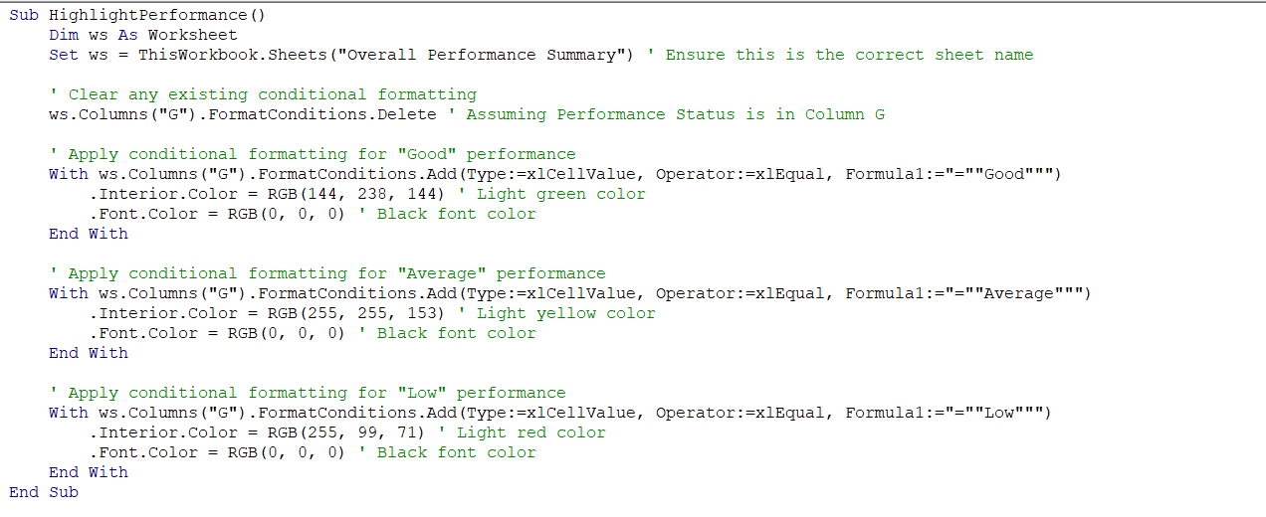](https://private-user-images.githubusercontent.com/98176045/364347744-009e88b5-c1dc-4e65-873c-b182bcfa7e67.png?jwt=eyJhbGciOiJIUzI1NiIsInR5cCI6IkpXVCJ9..KdywSqrWoeCNHpGLE-lTyCcxyK3-AjeXOss3uQlJdFw)

### 5.3 Conditional Formatting Macro:

* + **Function:** Apply conditional formatting to highlight exceptional performance metrics.
  + **Steps:** Created a macro that applies conditional formatting to engagement rate columns, coloring cells based on performance thresholds.
  + **Outcome:** Automated the process of visualizing high and low performers, making insights more accessible.

[](https://private-user-images.githubusercontent.com/98176045/364347790-d74a898b-2c40-4c1b-8979-75c0009a3791.png?jwt=eyJhbGciOiJIUzI1NiIsInR5cCI6IkpXVCJ9..8G9t41LGVjfytnwcemwfwV5kRVUd9BUJTeDg3N75_h8)

### Formatting Summary Sheet Macro:

* **Function:** Enhance the "Overall Performance Summary" sheet with consistent formatting.
* **Steps:**
  + **Header Styles:** Applies bold, white text on a dark blue background, centers text, and sets the font size to 12.
  + **Column Widths:** Adjust widths for columns A through G to fit data.
  + **Number Formatting:** Format columns for Engagement Rate, CPC, CTR, VTR, and Performance with appropriate number formats (percentage or currency).
  + **Autofit Rows:** Adjusts row heights to fit content.
  + **Borders:** Adds thin, continuous borders around the data range and inside cells for improved readability.
* **Outcome:** Creates a visually appealing and organized summary sheet, enhancing data presentation and readability.

[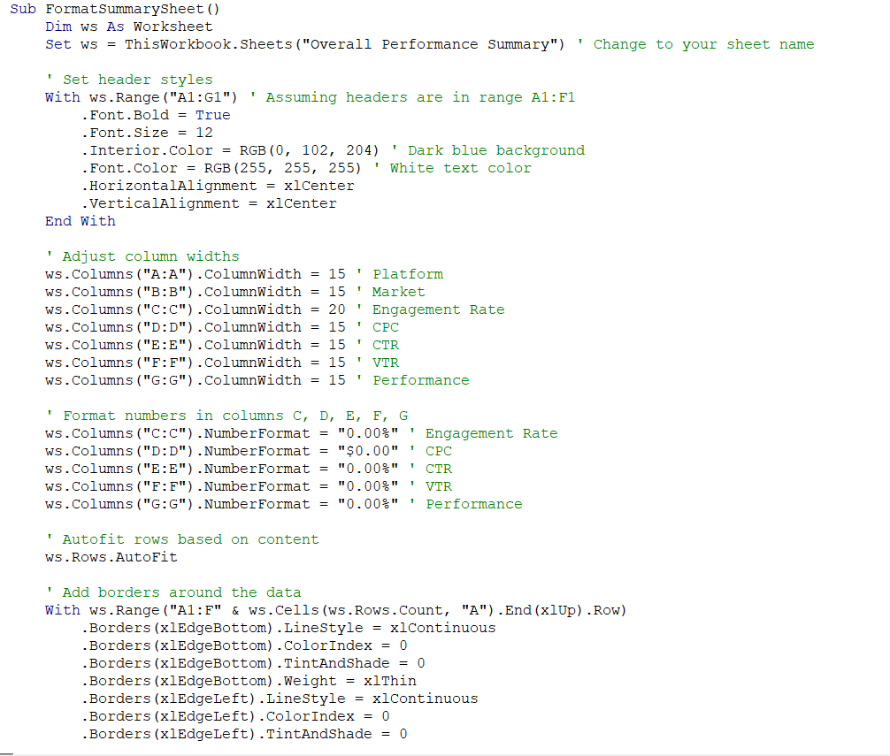](https://private-user-images.githubusercontent.com/98176045/364347902-9daadaeb-5154-4ec4-939a-b4658114b275.png?jwt=eyJhbGciOiJIUzI1NiIsInR5cCI6IkpXVCJ9..Kr1X1Tds9-AirHV0UmuVd1z7Pfgh5LeSFEJjmlcgQxk)[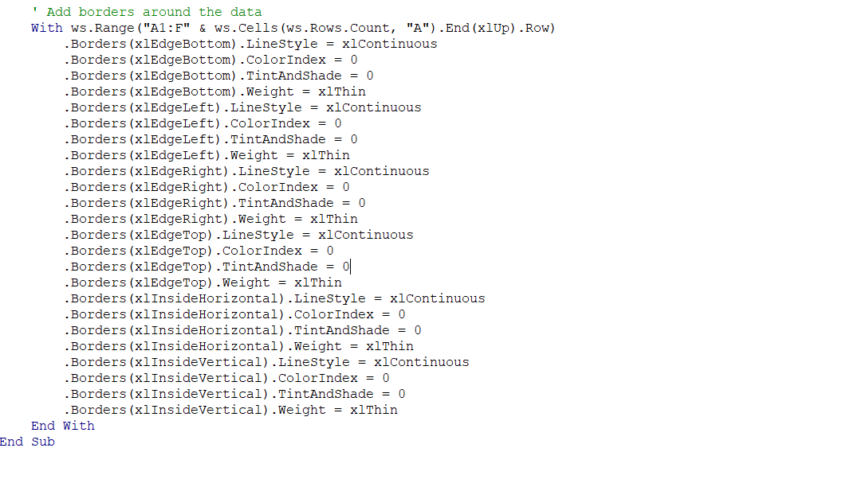](https://private-user-images.githubusercontent.com/98176045/364347947-79042187-19a7-48e2-9c47-e695d231fe64.png?jwt=eyJhbGciOiJIUzI1NiIsInR5cCI6IkpXVCJ9..78Q7C9VciVBubFzY8FDm4qOdmLIhPD-8fD_cDrFYiOs)

## Conclusion:

The comprehensive analysis of the Ramadan digital marketing campaign data across TikTok, Meta, and Snapchat yielded several crucial insights:

1. **Platform Performance:**
   * **TikTok** demonstrated the highest engagement rate at 0.3095, indicating robust user interaction. It also showed commendable conversion rates and visual representation metrics, positioning it as an effective platform for engagement-driven campaigns.
   * **Meta** showcased cost efficiency with a CPC of $120.78 and substantial click volumes, suggesting it offers value for money in terms of cost-per-click.
   * **Snapchat** had the lowest CPC but correspondingly low engagement and conversion rates, indicating that it may not be as effective for high-impact campaigns when compared to TikTok and Meta.
2. **Market-Specific Insights:**
   * The **AE (United Arab Emirates)** market excelled across both TikTok and Meta, demonstrating high engagement levels and significant total impressions, making it a key area for future campaigns.
   * **JED (Jeddah)** and **KW (Kuwait)** also displayed strong performance metrics, particularly in engagement and impressions on TikTok, which warrants increased attention in future efforts.
3. **Demographic Trends:**
   * **Millennials** (ages 25-34) exhibited higher click volumes and conversion rates compared to Boomers, indicating that campaigns targeting this demographic could yield more favorable results.

## 7. Recommendations:

1. **Focus on High-Performing Markets:** Prioritize markets such as AE and JED where high engagement and significant impressions were observed. Consider allocating more resources to these regions for upcoming campaigns.
2. **Target Engaged Demographics:** Develop campaigns aimed at Millennials, who demonstrated higher engagement and conversion rates. Explore strategies to enhance outreach to Boomers and other age groups for a broader impact.
3. **Utilize Platform Strengths:** Leverage TikTok for content designed to drive engagement and use Meta for cost-effective ad placements. Consider Snapchat for supplementary, targeted efforts if the budget allows.